EudraCT – Work Instruction

The programs for the following steps can be found here: FOLDER

Part A: Loading the Eutct formats

1. Check that the current formats program refers to the most up to date version number
2. Go to <http://eutct.ema.europa.eu/eutct/displayWelcome.do> and click on RMS

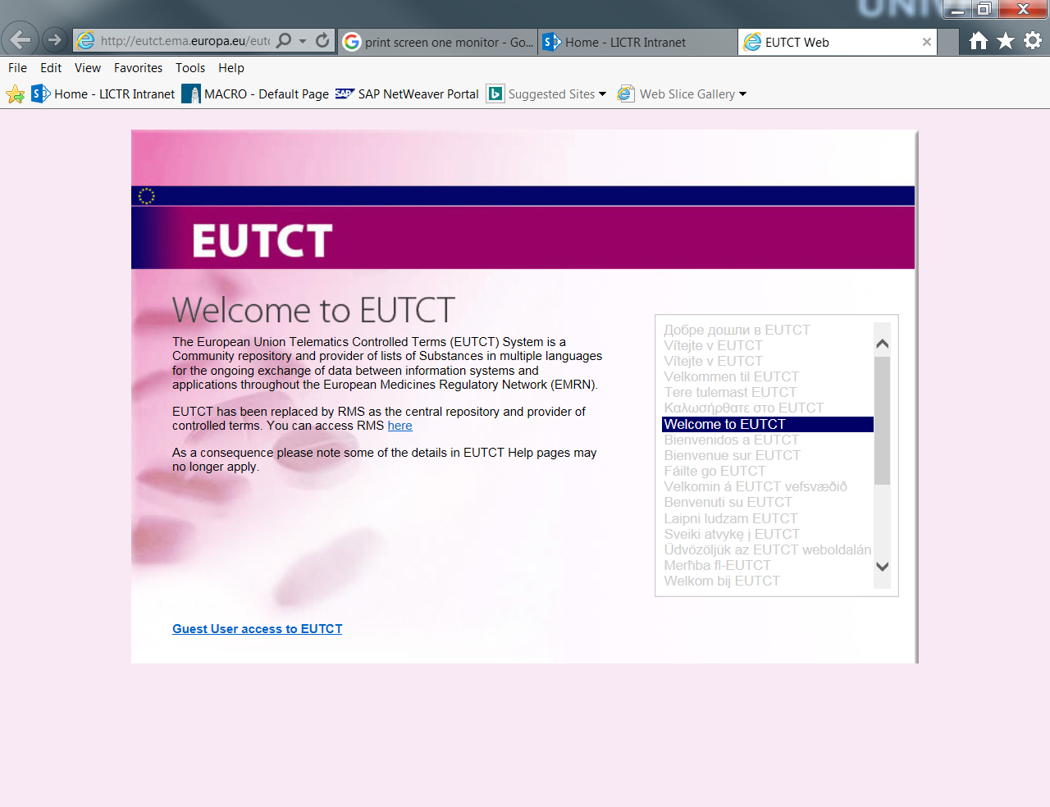

1. Click on lists and view lists. 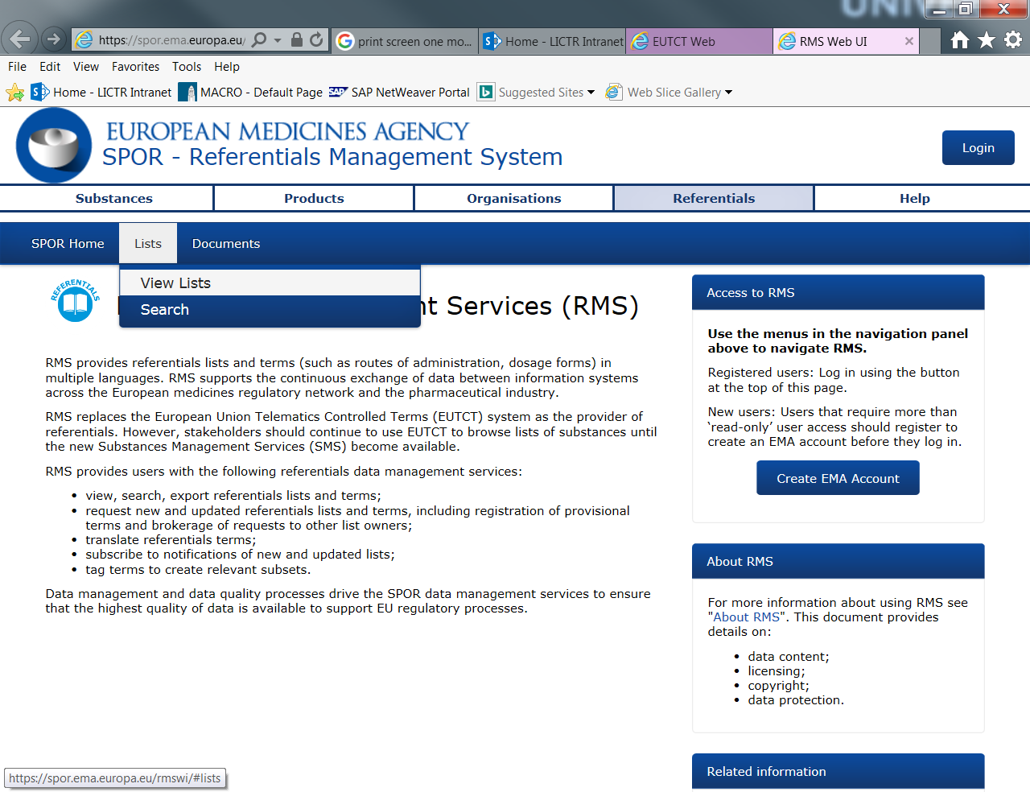
2. Find and click on Medical Dictionary for regulatory activities.

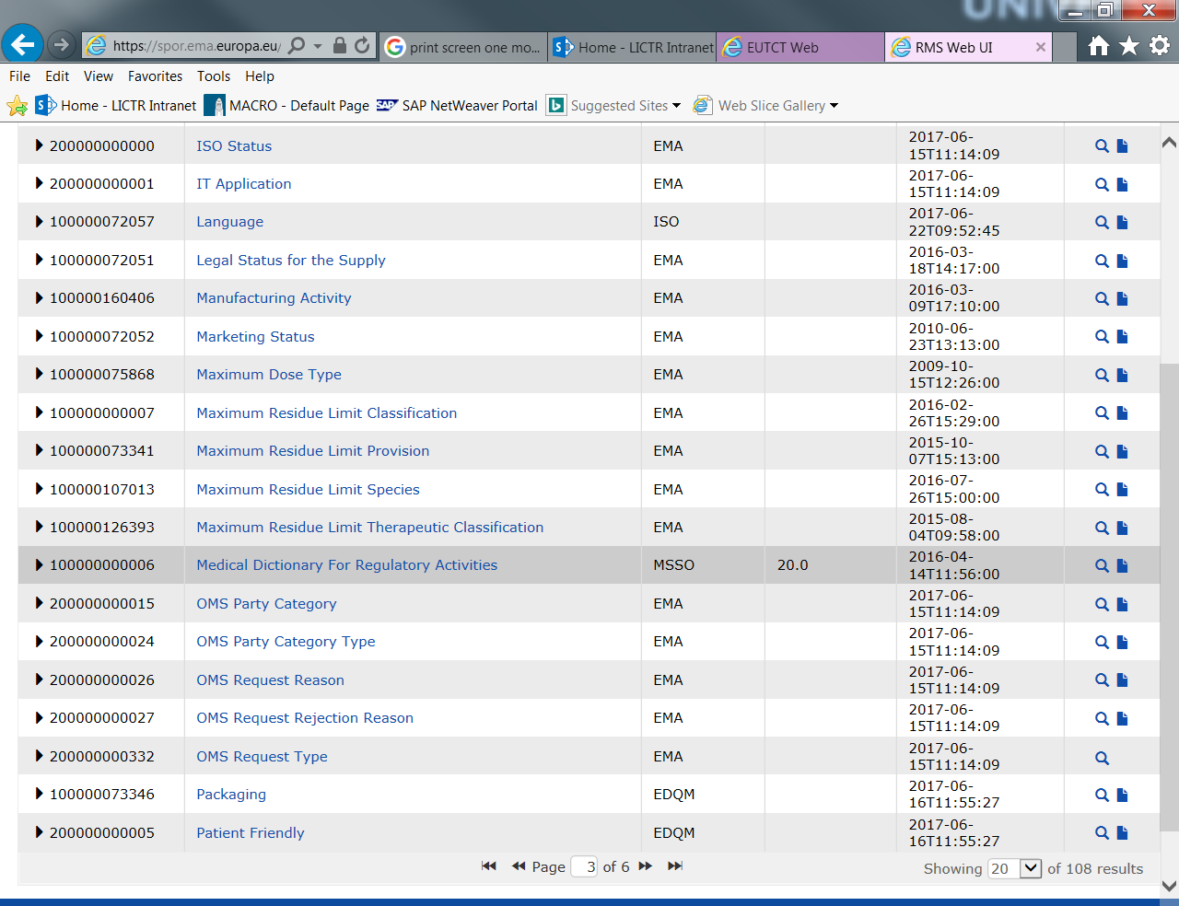

1. Click on any term in the list

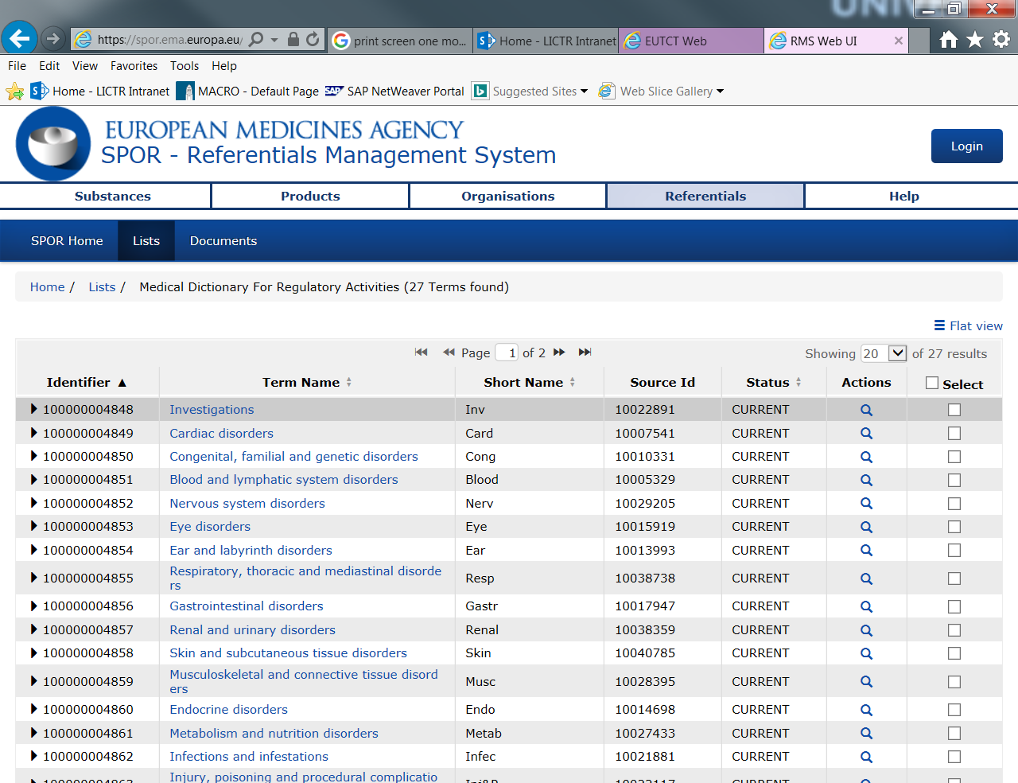

1. Expand “operational Attributes” and compare version number to that in formats program. Are they the same?

* Yes go to III
* No go to II

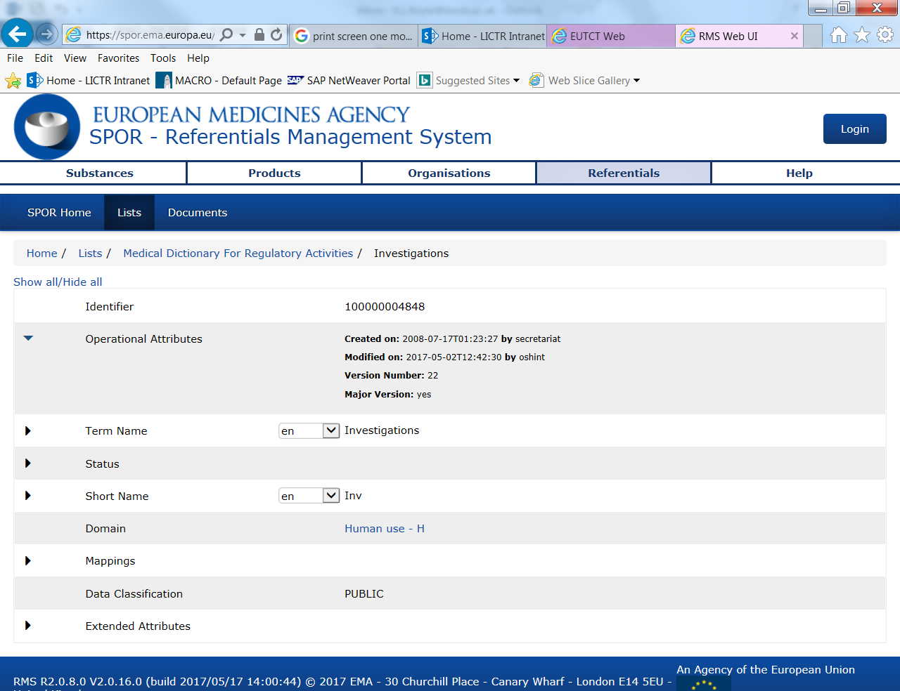

1. Updating the formats

* Supersede the previous version by saving it in the previous versions folder and suffix the program _VX where X is the previous number.
* Update the current file as required;
  + Update 'VersionNumber'= X to the new version number.
  + Compare and update if required the current assigned numbers to the ones in column “identifier” in step 4 of I.
* Log in the file the version number you initials and the date you updated the formats program.

1. Running the program
   * Copy the correct formats program into your trial’s EudraCT directory.
   * Update the libname to be the formats library for your trial’s EudraCT formats directory.
   * Update the header as appropriate.
   * Run the program.

Part B: Checking that your datasets are in the correct form

1. Copy the file into your trial’s EudraCT directory.
2. Update the header and directory as required.
3. Update the libname statement for the Eutct formats library.
4. Run the program in check order and check the log to see if any errors come up after each run. Error messages will say which of the three datasets have an existing violation.
5. Correct the errors in check order, some later errors fire if an above violation exists.
6. If an error persists check back to the datasets guideline to ensure everything is correct.

Part C: Creating the XML file

1. Copy the file into your trial’s EudraCT directory.
2. Update the header, directory, libname statements, file string, sasout string and saslog string as required.
3. Run the program
4. Check the log for errors.

Part D: Uploading to EudraCT

1. Go to <https://eudract.ema.europa.eu/> and click Login to EudraCT.

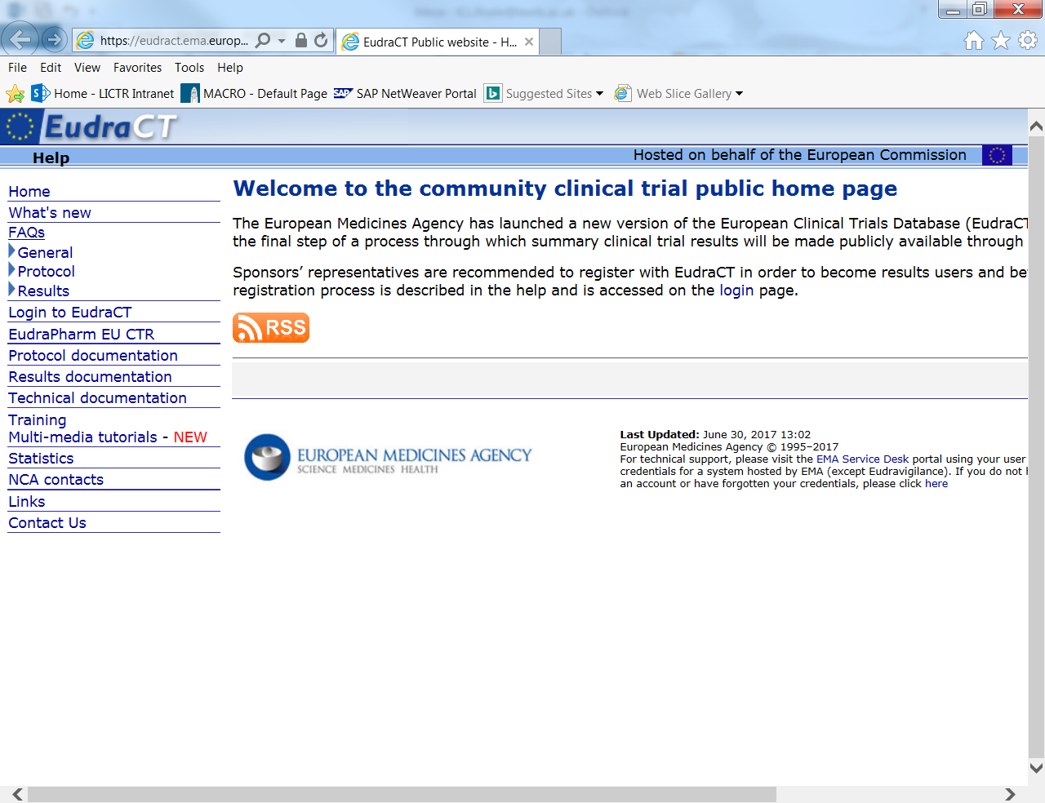

1. Login using your specific trial login.

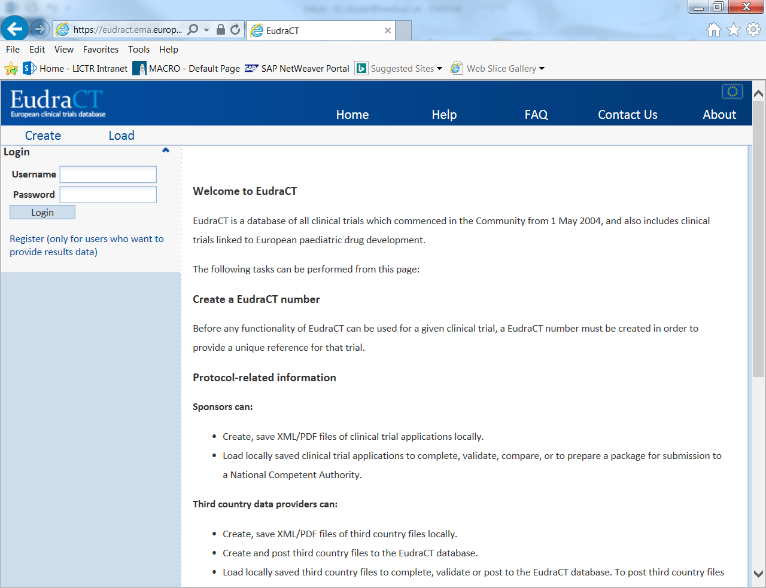

1. Click edit on the relevant trial

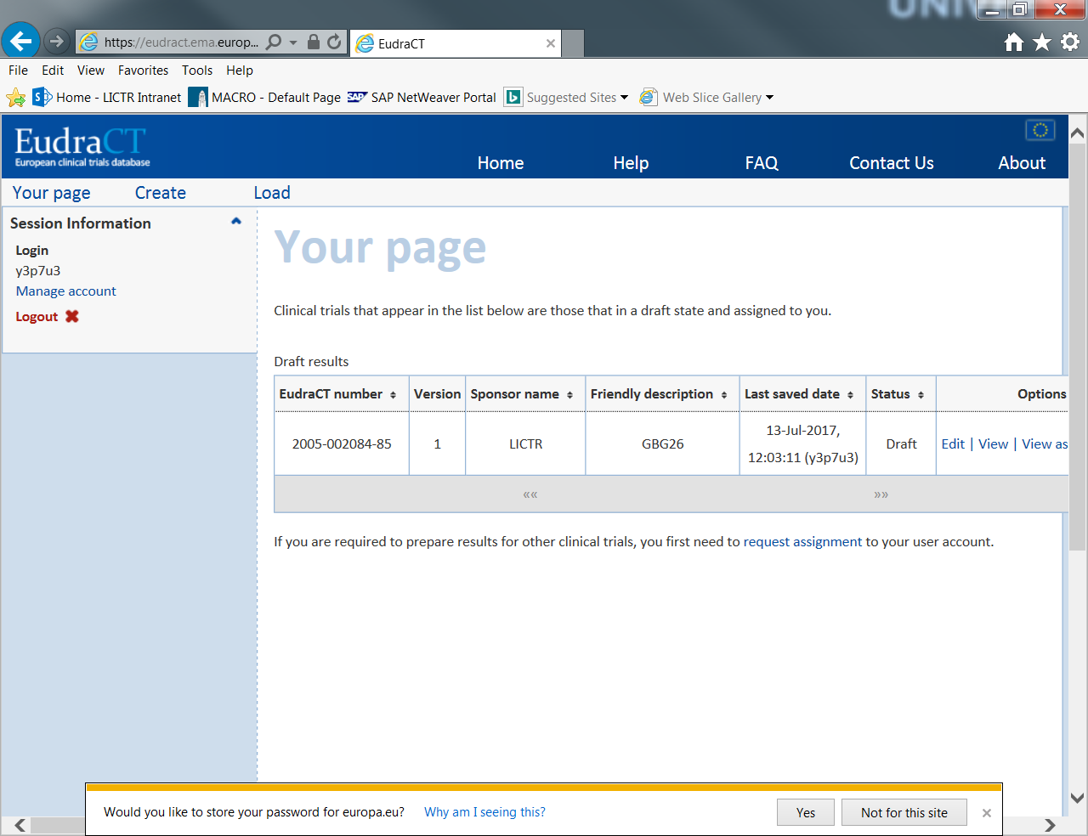

1. Click on Adverse events

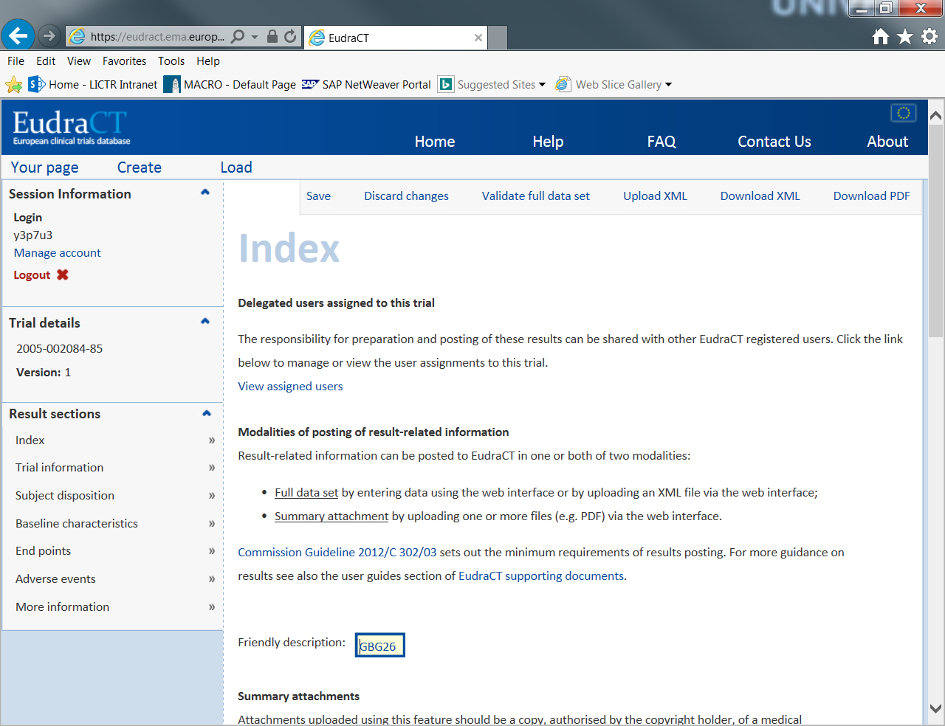

1. Fill in the required sections

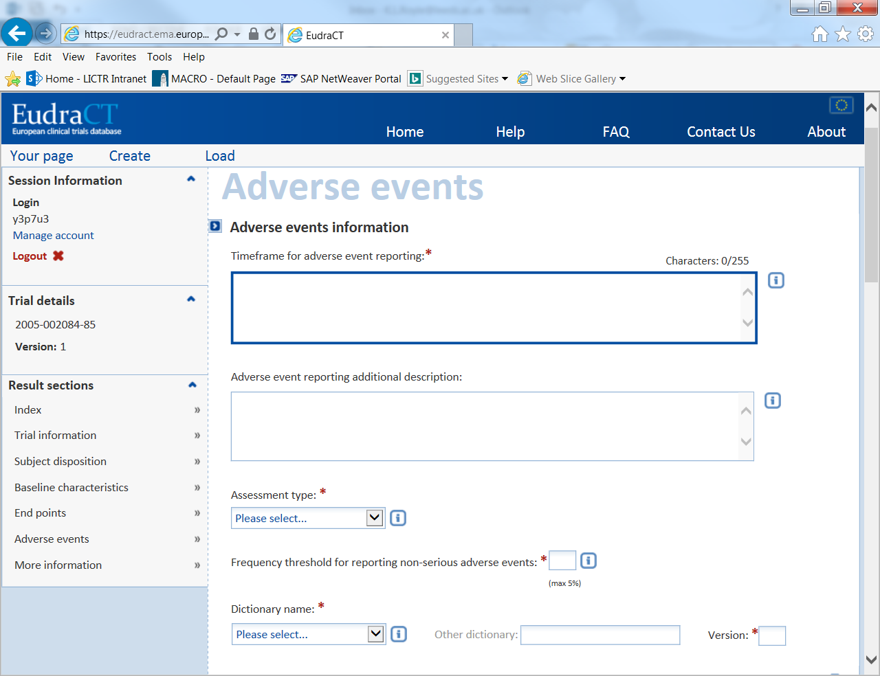

1. Click on “Upload XML”

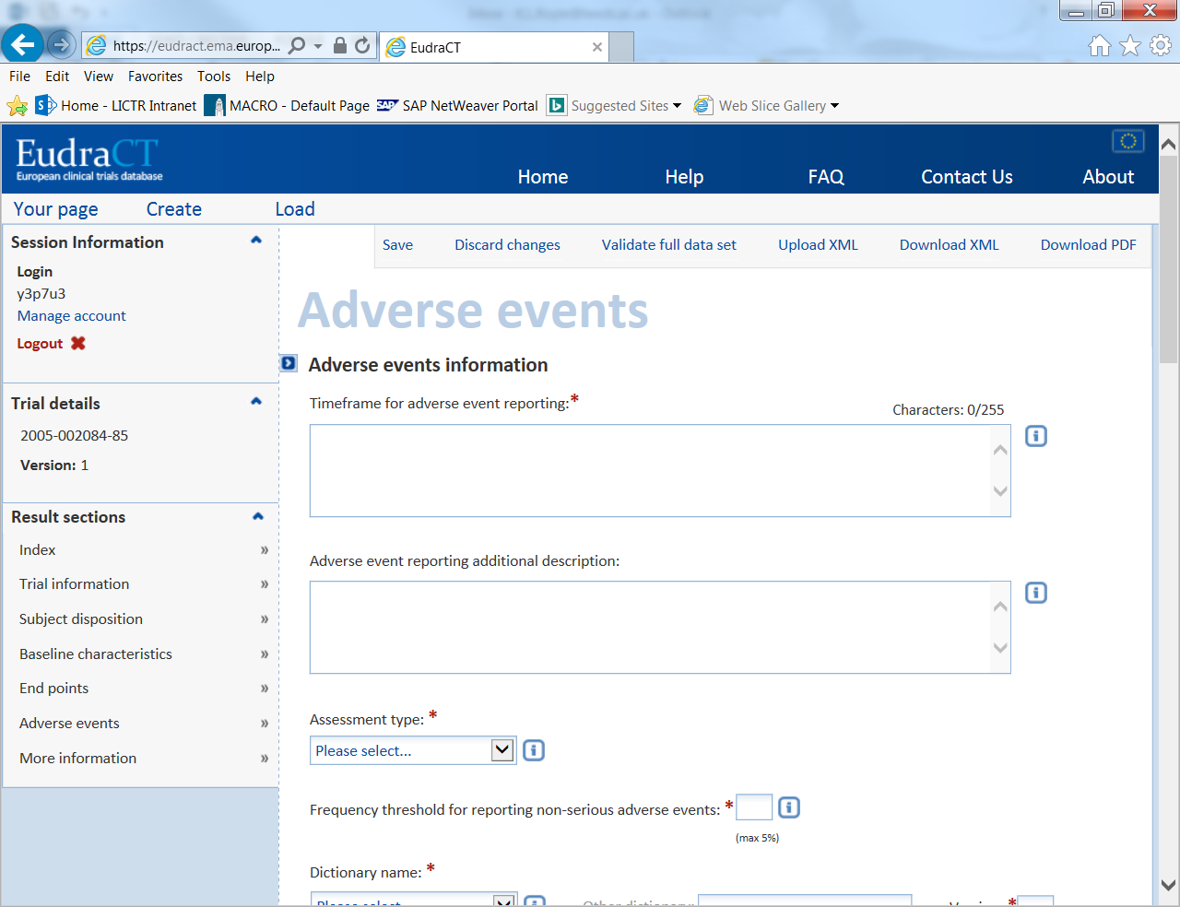

1. Click confirm

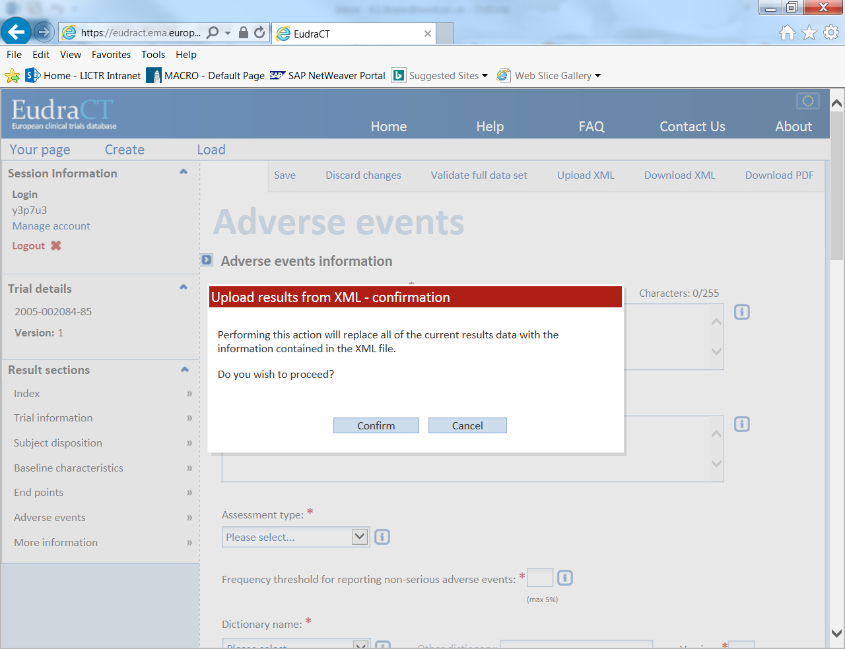

1. Change the type of file to “Adverse Events” and click +Add…

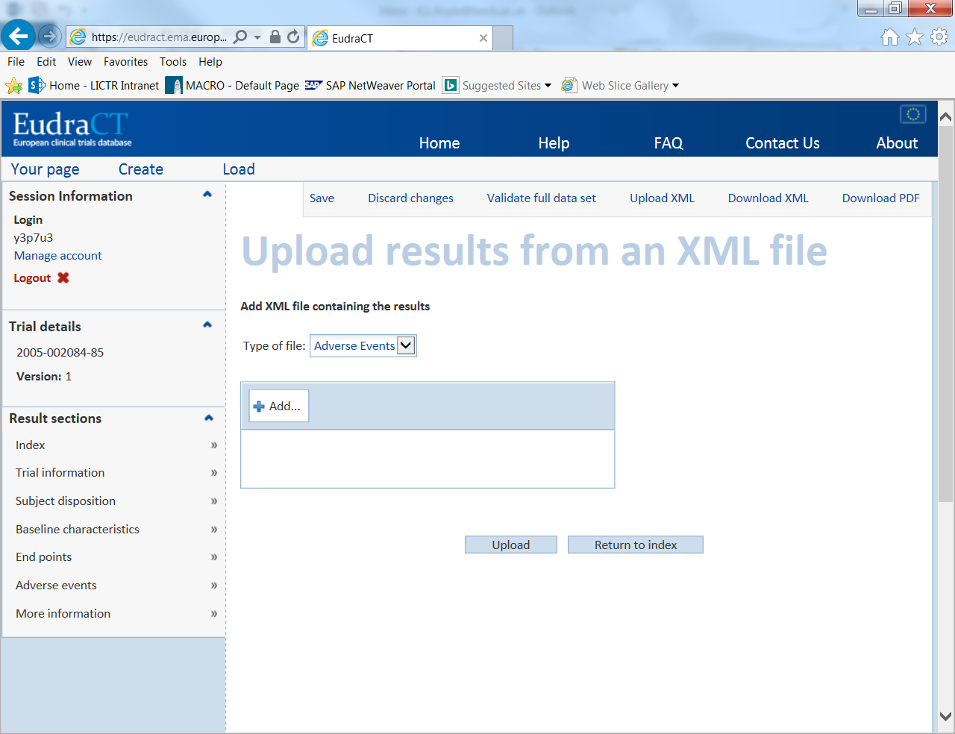

1. Find your outputted XML file and click open.

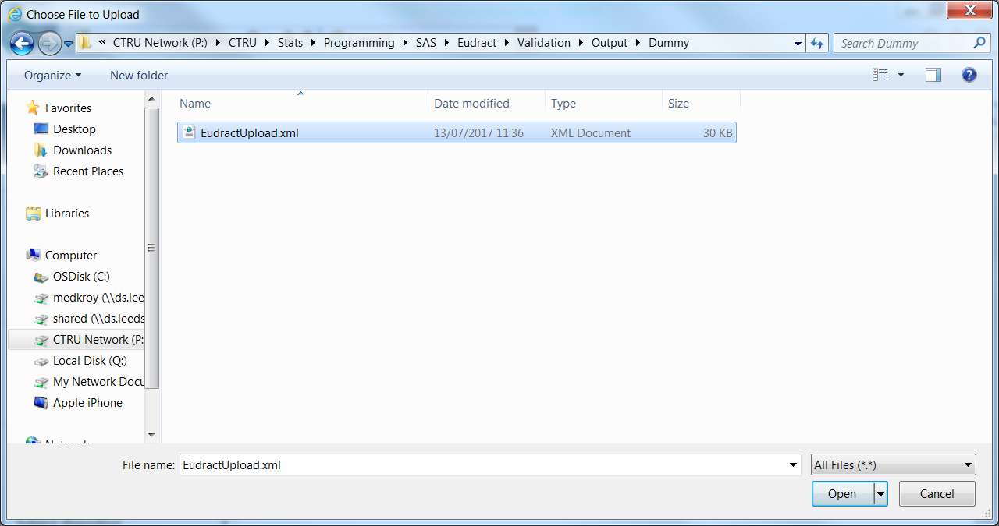

1. Click upload

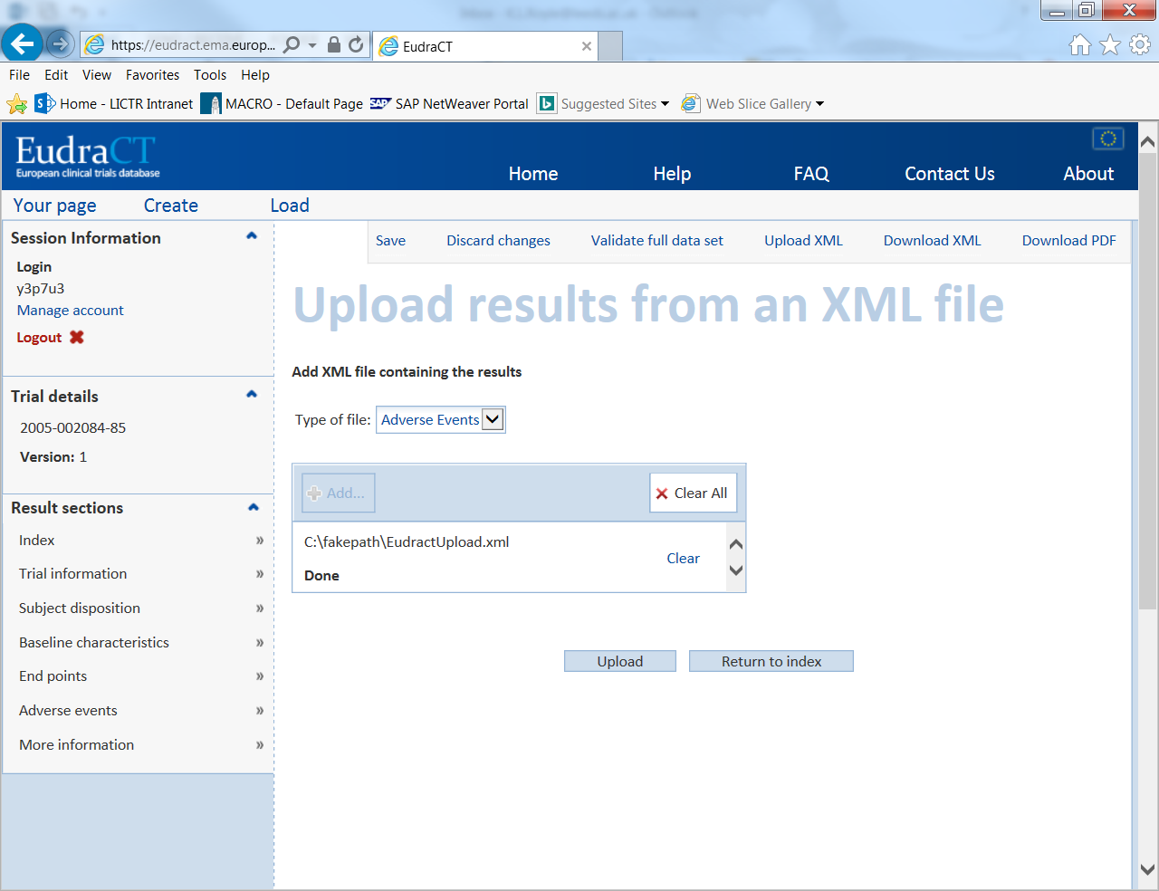

1. If successful you should get the following message, click ok.

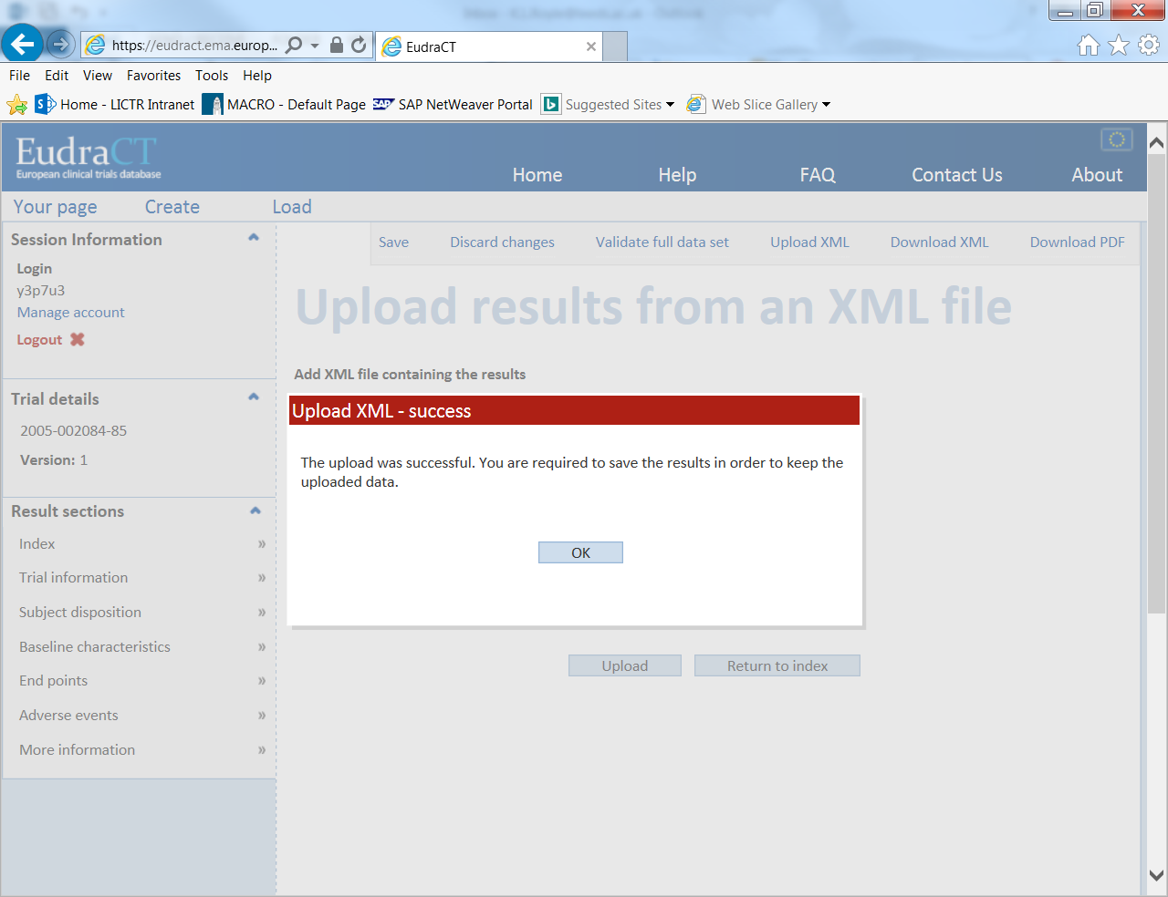

1. This will take you back to the homepage, click on Adverse events and check that your data has uploaded correctly. For example:

